New From NK Technologies
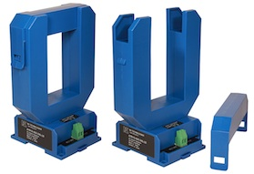

AT/ATR-LS Series
AC Current Transducers
AT/ATR-LS Series Current Transducers combine a current transformer and signal conditioner into a single package. The large, easy-to-install split-core design allows for ease of installation over new or existing conductors without the need to disconnect the load, even in applications where there are multiple conductors per phase. Just remove the top portion of the sensing ring, place the conductors inside, and snap the top back in place. The transducer uses two wires to connect to the power supply and the load, programmable logic controller, panel meter or data acquisition system.

Click on link for Data Sheet
AT/ATR-LS Series AC Current Transducer
If you have any questions, please contact Trask Instrumentation Inc., your local stocking NK Distributor, at 864-848-3993 or mike@traskinst.com
Trask Instrumentation 414 West Poinsett Street Greer, SC 29650

